
NITROXHIFT STUDIOS
Web Development Internship 2026
DIGITAL SKILLS PLATFORM
Instructor Dashboard

Prepared by: Dania Nadeem
Date: August 2026

WEB DEVELOPMENT ITERNSHIP
FINAL TASK

Project: Digital Skills Platform
Module: Instructor Dashboard
Frontend: React.js + Vite
Backend: FastAPI
Database: PostgreSQL
API: REST API

Digital Skills Platform

Project Title
Digital Skills Platform - Instructor Dashboard

Introduction
The Digital Skills Platform – Instructor Dashboard is a full-stack web application developed as an individual Week contribution for Nitro Solutions. The dashboard is designed to help instructors manage courses, view students, track student progress, and manage grades.
The application uses React.js for the frontend, FastAPI for the backend, PostgreSQL for the database, and REST APIs for communication between the frontend and backend.
The project demonstrates practical skills in full-stack web development, API development, database management, responsive UI design, and Git/GitHub version control.

Project Overview
The Digital Skills Platform – Instructor Dashboard was developed as an individual Week contribution for Nitro Solutions. The main purpose of this module is to provide instructors with an easy-to-use interface for managing courses, viewing students, tracking student progress, and managing grades.
The project is a full-stack web application developed using React.js, FastAPI, PostgreSQL, and REST APIs.

Project Objective
The objective of this project is to build an Instructor Dashboard that allows instructors to:
- Create, edit, and delete courses
- View registered students
- View and update student progress
- Add, view, and delete student grades
- Login and manage their instructor account

Technologies Used
Frontend: React.js, Vite, JavaScript, HTML5, CSS3
Backend: Python, FastAPI, Pydantic, SQLAlchemy
Database: PostgreSQL
Tools: Visual Studio Code, Git, GitHub, Swagger UI, pgAdmin

How the System Works
The application follows a simple full-stack architecture:
React Frontend
↓
REST API
↓
FastAPI Backend
↓
PostgreSQL Database
The instructor interacts with the React dashboard. The frontend sends requests to the FastAPI REST API. FastAPI processes the requests and stores or retrieves data from PostgreSQL using SQLAlchemy.

Main Features

Authentication
- Student and Instructor registration
- Login functionality
- Role-based dashboard
- Logout

Course Management
- Create courses
- View courses
- Edit courses
- Delete courses

Student Progress
- View student progress
- Update progress from 0% to 100%

Grade Management
- Add student grades
- View grades
- Delete grades
- Marks validation from 0 to 100

Database Management
The PostgreSQL database contains the following main tables:
- Users
- Courses
- Enrollments
- Progress
- Grades

Challenges and Solutions
During development, an Unknown Course issue occurred because some progress records referred to courses that had already been deleted. This was solved by retrieving course information using course_id and deleting related progress, grades, and enrollment records when a course is deleted.
Another challenge was communication between the React frontend and FastAPI backend. This was resolved by configuring CORS in FastAPI.

How to Run the Project

Backend
cd backend
uvicorn main:app --reload
Backend:
http://127.0.0.1:8000
Swagger:
http://127.0.0.1:8000/docs

Frontend
cd frontend
npm install
npm run dev
Frontend:
http://localhost:5173

Testing
The following features were tested successfully:
- Registration and Login
- Instructor Dashboard
- Course CRUD operations
- Student management
- Progress management
- Grade management
- PostgreSQL database operations
- REST APIs through Swagger
Screenshots
Figure 1: SignupPage
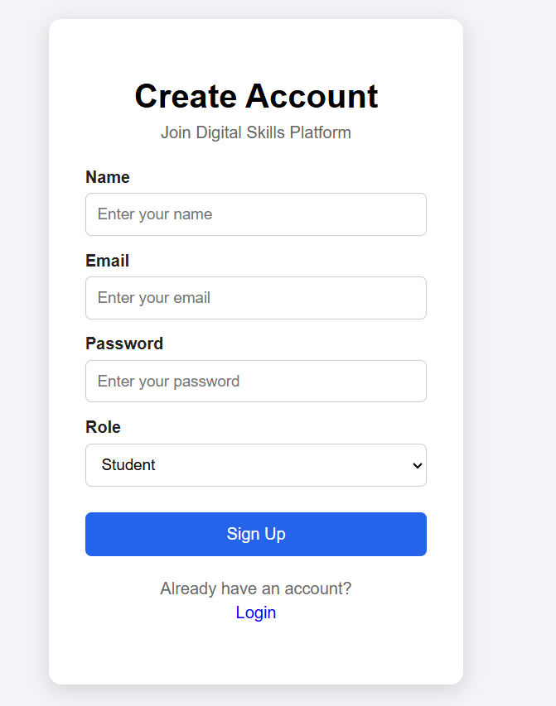
Figure 2: Login Page
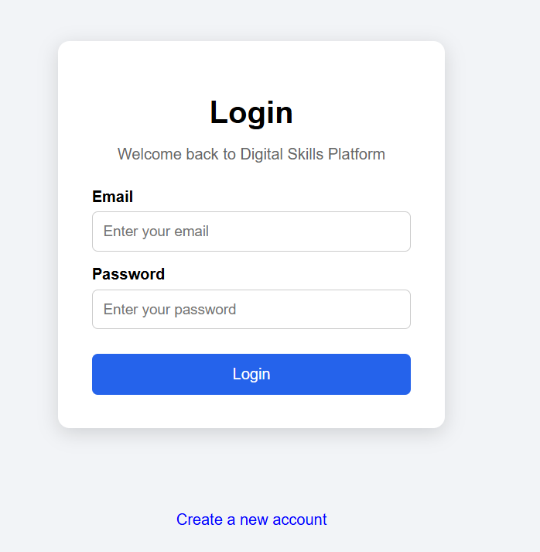

Figure 3: Instructor Dashboard
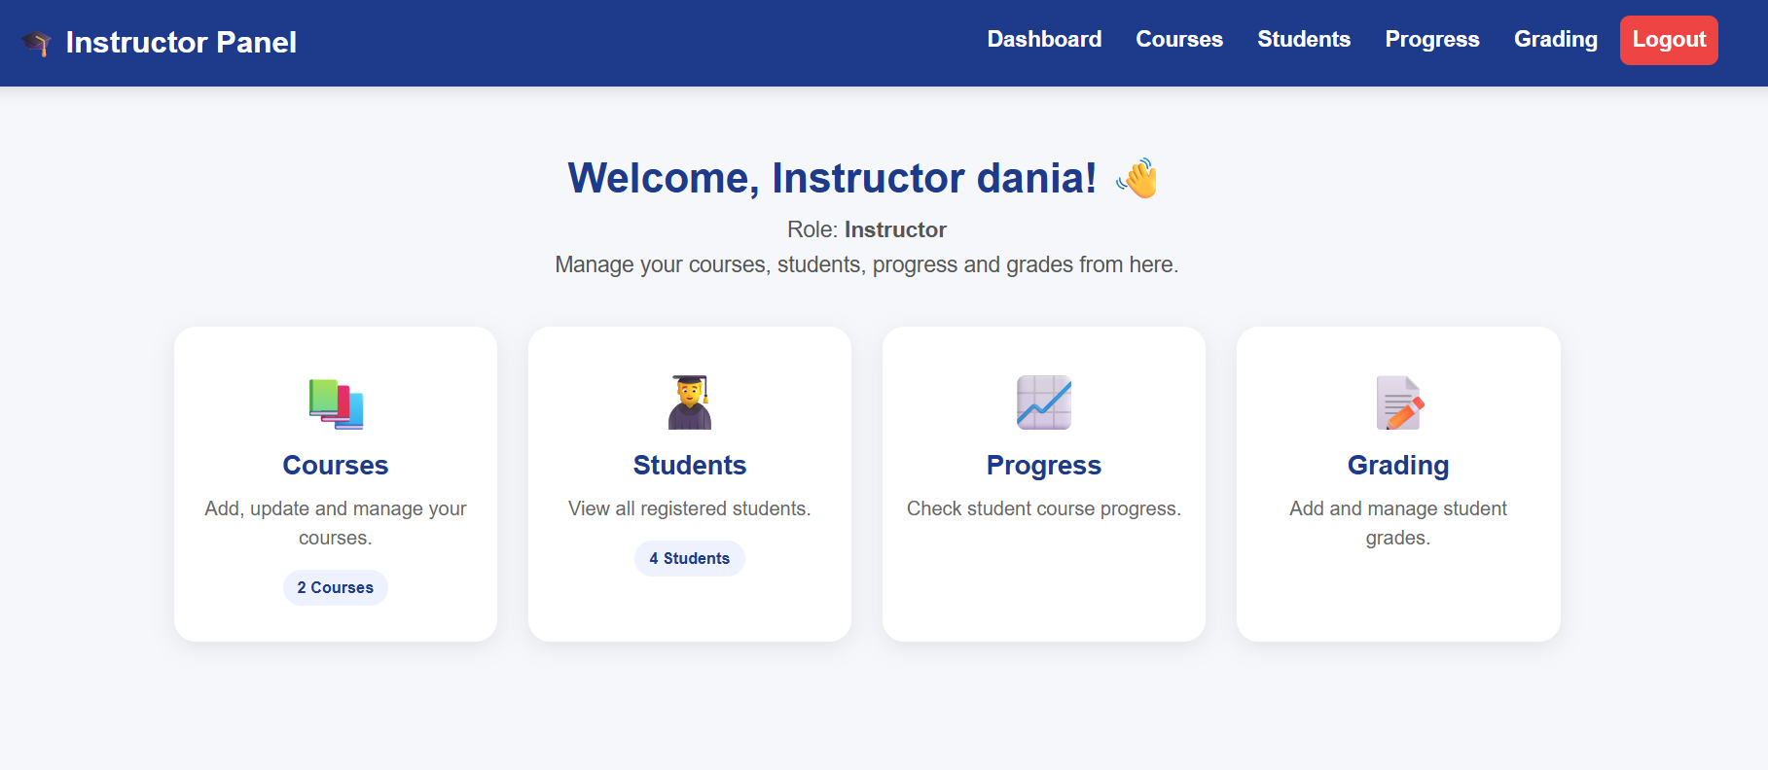

Figure 4: Course Management
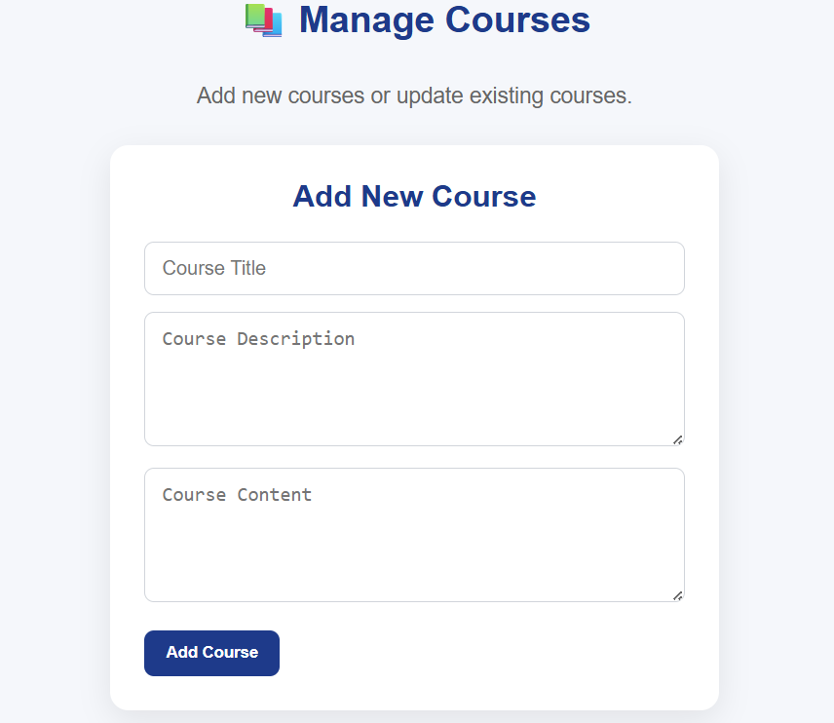
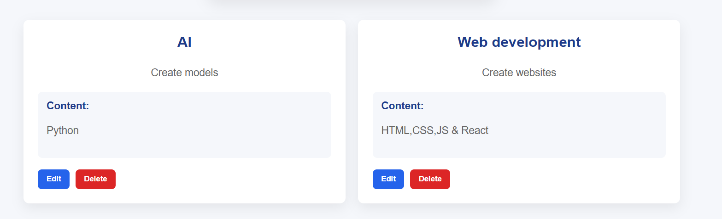

Figure 5: Edit Course
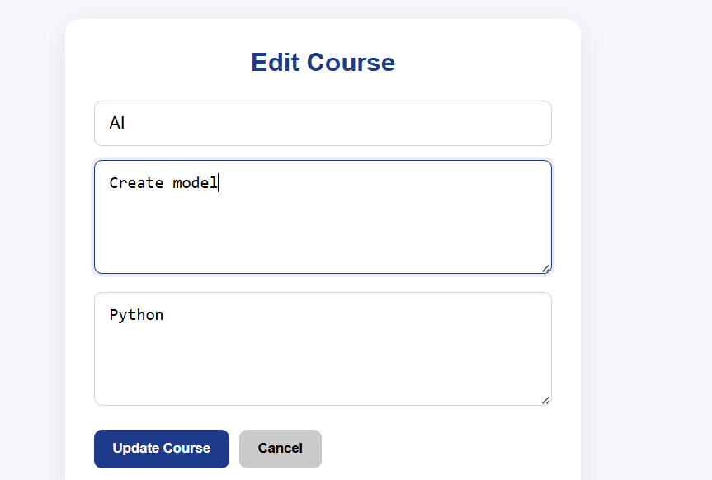
Figure 6: Students
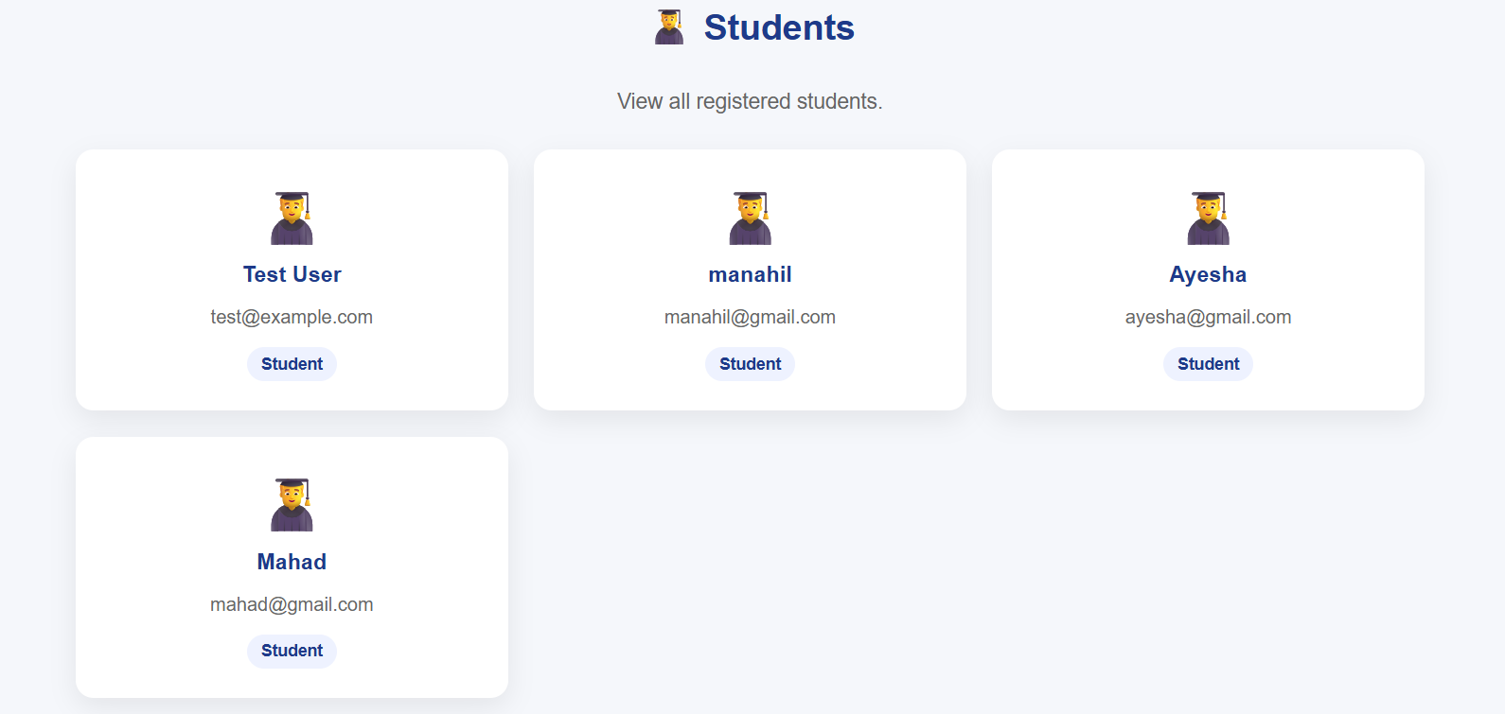

Figure 7: Student Progress
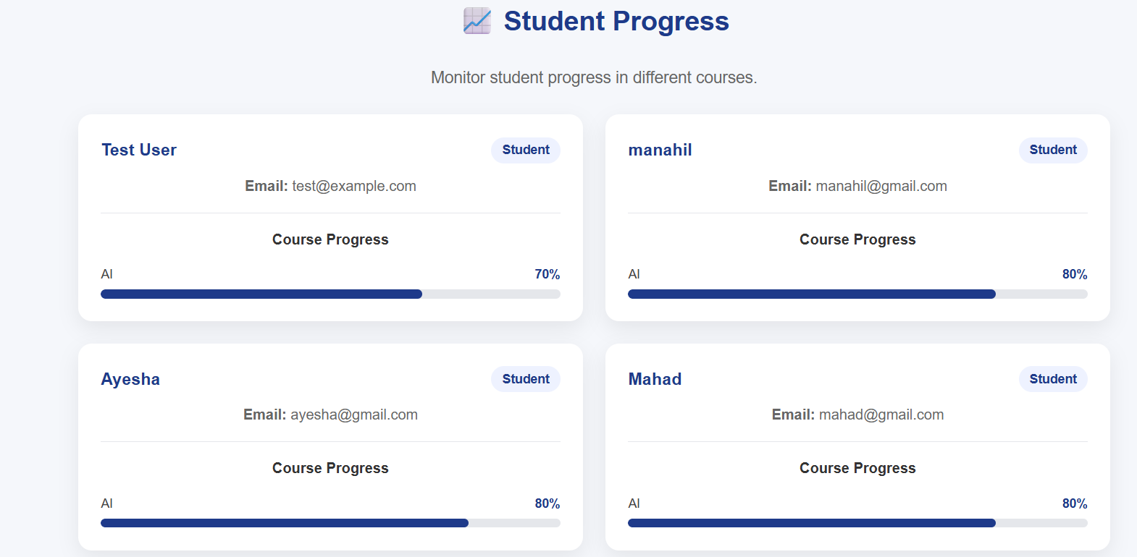
Figure 8: Grade Management
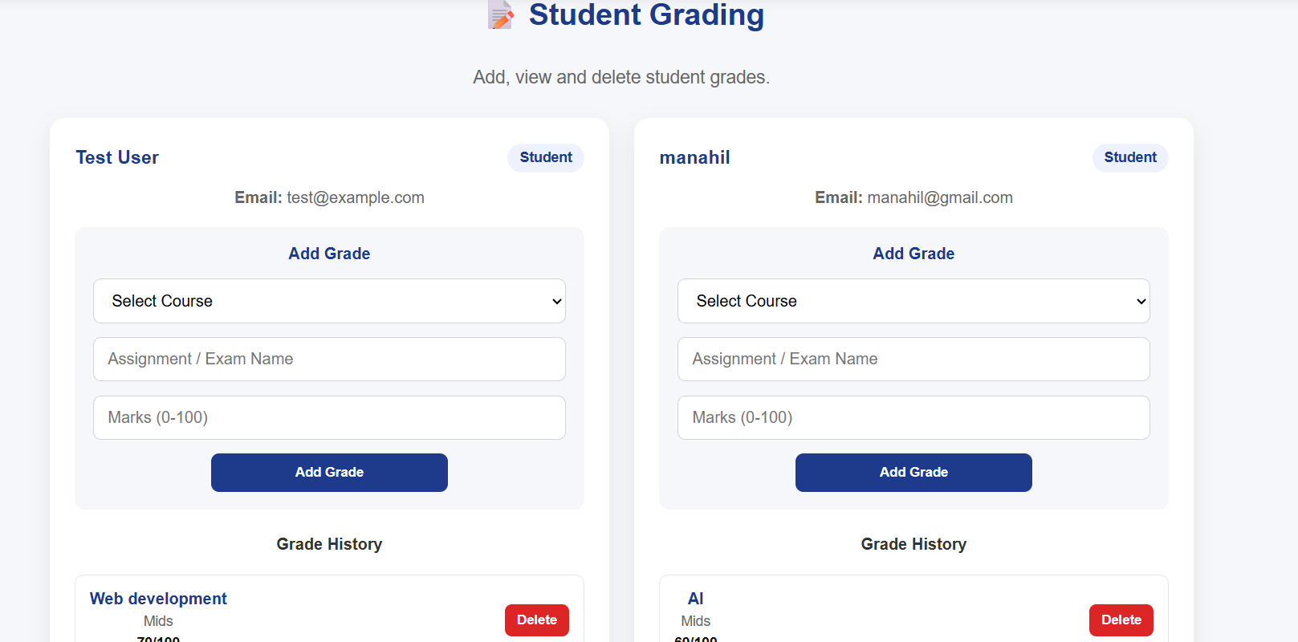
Figure 9: Swagger API
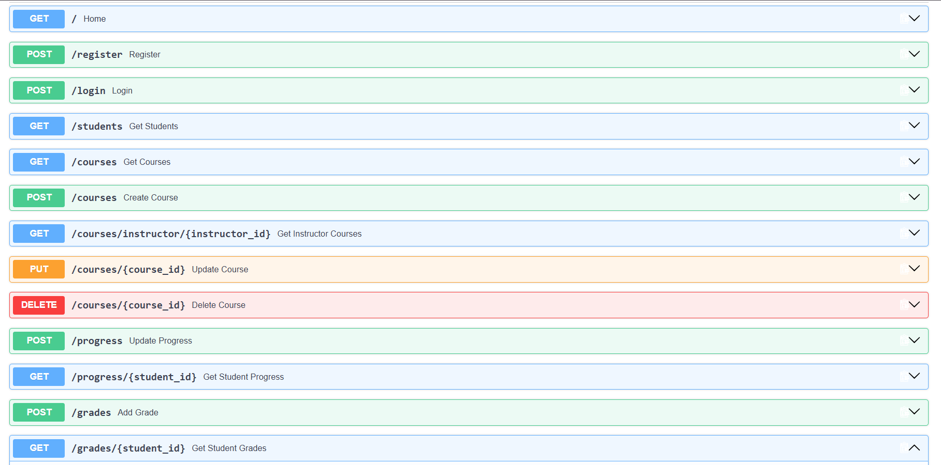
Figure 10: PostgreSql
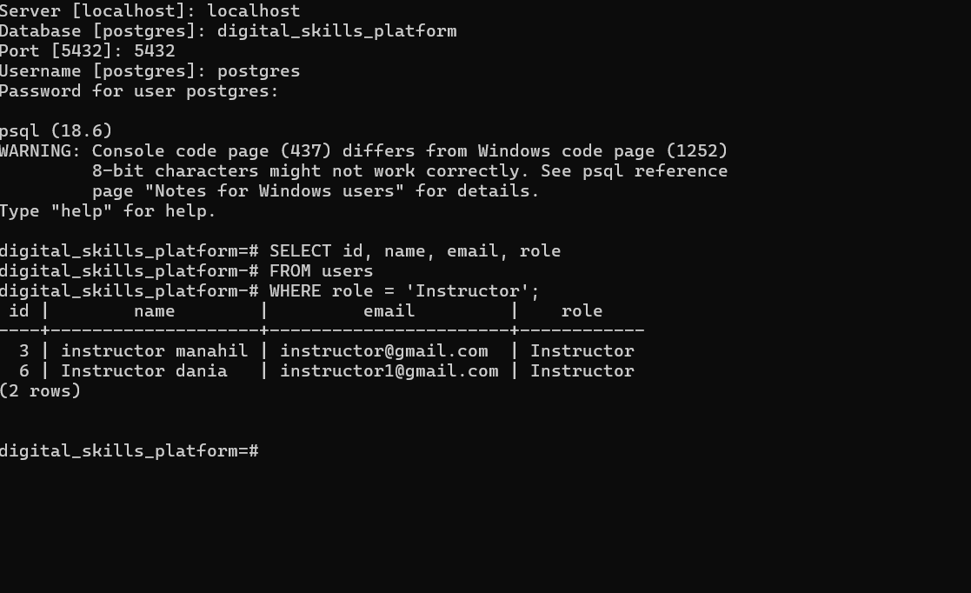

Conclusion
The Instructor Dashboard successfully implements the main requirements of the Week contribution. It provides instructors with a centralized system for managing courses, students, progress, and grades.
This project provided practical experience in full-stack web development, REST API development, PostgreSQL database management, responsive UI design, debugging, and Git/GitHub version control.

Progress Report

Task | Status

React/Vite Setup | Completed
Instructor Dashboard | Completed
Authentication | Completed
Course Management | Completed
Add Course | Completed
Edit Course | Completed
Delete Course | Completed
Student Management | Completed
Student Progress | Completed
Grade Management | Completed
Grade Delete | Completed
FastAPI REST APIs | Completed
PostgreSQL Database | Completed
Responsive UI | Completed
API Testing with Swagger | Completed
GitHub Repository | Completed
README | Completed
Screenshots | Completed
Documentation | Completed
Final Working Demo | Completed

Explanation Video | Completed

